Position title | Senior Lawyer
Employment status | Fixed Term/ Perm
Classification | SACS
Reports to | Principal Lawyer
Stream | All streams
Last Reviewed | June 2026

Who we are

Circle Green Community Legal is a community legal centre in Western Australia that supports people who face disadvantage or marginalisation across specialist areas of law. With a strong commitment to human rights, access to justice, and a more just legal system, Circle Green provides free legal services across employment, tenancy, family and domestic violence, and humanitarian immigration law.

Our Vision

Empowered people thriving in a just society.
Our vision reflects a commitment to fostering fairness, dignity, and opportunity so every person can flourish in communities supported by systems that uphold equity and remove barriers.

Our Purpose

Accessible Justice.
To create a system, place, and space to ensure a safety net of best-practice legal advice, education and advocacy.

Values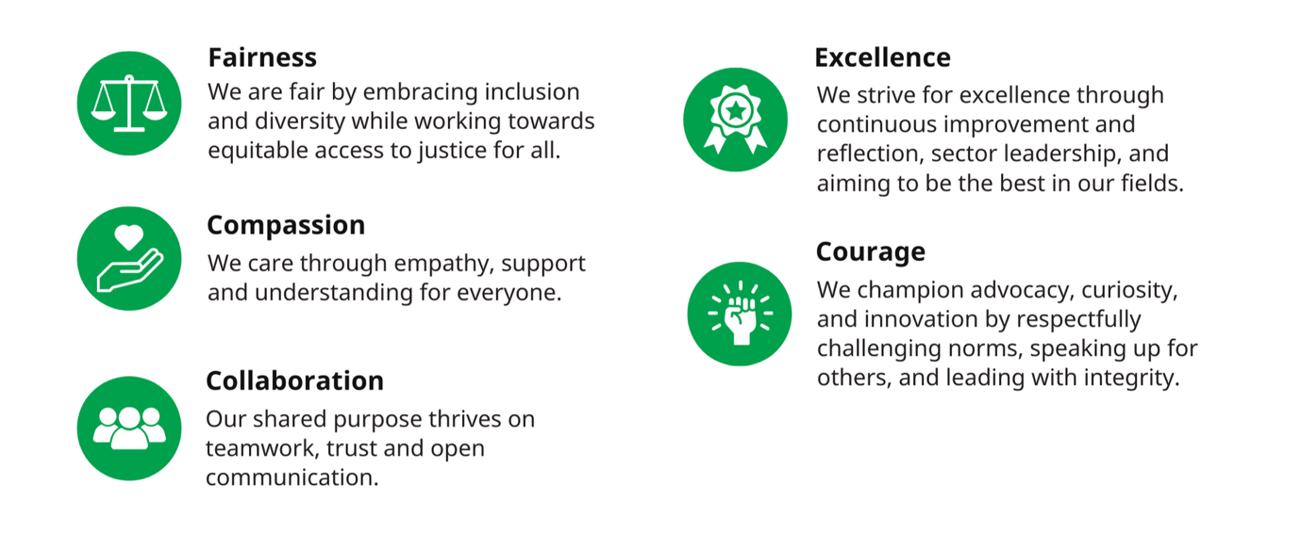

Role Contribution
Senior Lawyers are required to provide comprehensive legal advice, further assistance, representation, community legal education and training, and law reform under the supervision of the Principal Lawyer. Senior Lawyers will also be involved in the direct supervision and management of lawyers, restricted lawyers, law graduates, advocates, secondees and volunteers.

Key relationships
Internal and External Stakeholders.

Key responsibilities
Legal Supervision

- Supervise and train restricted Lawyers, law graduates, advocates, secondees, and volunteers.
- Support the supervision and training of unrestricted Lawyers.
- Supervise the Intake and Triage team on rotation with other Lawyers.
- Review triage, overview new client assessments, and monitor client intake process.
- Participate in regular file review meetings for legal staff.
- Provide regular reports to the Principal Lawyer regarding caseload and matter types.
- Ensure compliance with professional indemnity and risk management obligations as a nominated person.

Client Work

- Provide legal advice, casework and representation services, including shadow lawyer, representation in
- Provide further assistance to clients in compliance with casework guidelines and policies.
- Be an ongoing point of contact and liaison for existing clients, providing information, and assisting with arrangements for further service delivery in conjunction with the Case Manager and Principal Lawyer.
- Work with interpreters as needed.
- Represent clients in legal proceedings or dispute resolution processes.
- Provide duty lawyer services.
- Conduct regular file reviews (at least monthly).
- Research legal problems and options.
- Identify and undertake potential test cases within relevant area of law.
- Prepare files for closing.

Strategic Legal Review and Advocacy

- Ensure appropriate compliance with guidelines and policies.
- Identify future legal needs of clients and potential clients.
- Supervised by Principal Lawyer, contribute to law reform and policy change.
- Monitor compliance with all funding requirements in conjunction with the Principal Lawyer and Administration Officer.
- Liaise with Community Legal Centres and other organisations providing complementary services.

Community Legal Education

- Develop and promote community legal education initiatives.
- Facilitate and present community legal education courses.
- Develop specialised community legal education resources, including fact sheets.

Team Responsibilities

- Implement Circle Green’s policies and procedures and act in accordance with the
- organisation’s mission and values.
- Participate in Circle Green’s team meetings and planning and review activities.
- Carry out other duties, consistent with the role, as directed by the Principal Lawyer.
- Carry out other duties, consistent with the role, as directed by the Principal Lawyer; including performing the responsibilities of the Principal Lawyer when the Principal Lawyer is on leave.
- Provide support and assistance to the Principal Lawyer in relation to staff management and leadership with the legal practice.

Selection criteria
Essential

Credentials
- Law degree.
- Admitted, or eligible for admission, as a legal practitioner in the Supreme Court of Western Australia and eligible to hold an unrestricted WA practising certificate.
Experience
- At least 5 years’ post admission experience in relevant area of law.
- Experience supervising and mentoring junior legal staff.
- A demonstrated commitment to human rights and social justice issues.
- Extensive migration law experience.

Skills
- Excellent written and verbal communication skills, with the ability to understand and convey complex concepts to people from diverse social, cultural, and linguistic backgrounds.
- Ability to effectively time manage a high and diverse workload.
- Ability to work with minimal supervision and be an effective team member.
- Demonstrated problem solving, negotiation and conflict resolution skills.
- Demonstrated ability to conduct case work and litigation, including advocacy skills.

