CANDIDATE INFORMATION PACK
Chief Executive Officer
Lead strategy. Build influence. Strengthen sustainability. Shape a culture that enables impact.
WELFARE RIGHTS CENTRE  Surry Hills, Sydney  Full time | A rare opportunity to lead a specialist Community Legal Centre at an important point in its evolution - protecting an essential social justice mission while building the strategy, funding and organisational resilience required for the future.

A LEADERSHIP OPPORTUNITY WITH PURPOSE
Welcome from the Chair

For more than 40 years, Welfare Rights Centre has supported people to access social security entitlements through one of Australia’s most complex and consequential systems. Our work changes individual lives, achieves systemic outcomes that benefit widely, builds the capability of the community sector and contributes to a fairer social security system.  We are now looking for a CEO who can honour that legacy while leading the Centre confidently into its next chapter. This is not a caretaker role. The Board is seeking a dynamic, values-led leader who can sharpen our strategic choices, strengthen our external influence and build a more sustainable funding base.  The successful candidate will bring political judgement, financial acumen and a willingness to pursue new opportunities. They will also be an experienced people leader who understands that organisational change succeeds when purpose, clarity, accountability and culture move together. | You do not need to be a lawyer. Our specialist legal expertise is central to who we are and is led by our Principal Solicitor. What matters is that you are passionate about the Centre’s purpose, can learn the policy and operating landscape quickly and can create the conditions in which our expert team can do its best work.  The Board has identified four priority focus areas for the role: strategy; representation and fundraising; people leadership; and improving operations. In the near term, financial sustainability and income diversification will require particular focus. We are looking for someone who can face that challenge directly, bring others with them and turn relationships and ideas into durable opportunities.  If you are motivated by social justice and excited by the opportunity to combine influence, enterprise and organisational leadership in service of a vital mission, we encourage you to consider this role.  Darren Dick  Chair, Welfare Rights Centre

OUR PURPOSE
About Welfare Rights Centre

Welfare Rights Centre is a specialist community legal centre helping people in NSW who have a problem with Centrelink. We provide free legal information, advice and representation, community worker training, and advocacy for systemic reform.  Our vision  A fair, just, accessible and adequate social security system that provides all people with the resources they need to lead a life which is meaningful to them.  Our work spans four connected fronts:  - Advice and representation for people affected by Centrelink decisions.  - Community worker training that builds capability across the broader support system.  - Targeted access and information for First Nations people and other communities facing barriers.  - Law reform and advocacy informed by what we see through casework and community engagement. | STRATEGIC GOALS  1  Centrelink held to account for unfair and unjust decisions  We will provide accessible legal advice and representation to people with social security law matters where there is a high benefit to clients from identified priority groups and/or that have the potential to remedy problems in the social security system.  2  An empowered community sector  We will support the community sector to develop and embed capability to resolve their clients' Centrelink problems.  3  Systemic change  We will publicly advocate for reforms that will result in a fair, just, accessible and adequate social security system.  4  A thriving organization  We will maintain and develop a well-resourced, robust, ethical and effective organisation.
WHY THIS ROLE, WHY NOW
The opportunity

We are seeking an active leader with a track record in leading change and driving strategy. Demand for our support continues to outstrip capacity, the policy environment is complex, and the Centre needs to strengthen its financial resilience while protecting the quality and independence of its work.  The next CEO will move beyond maintaining existing settings. Working with the Board and leadership team, they will set a clear strategy for the next phase, focus resources on the highest-impact priorities and build a funding model that is less vulnerable to any one source of income.  That means being comfortable with both mission and money: understanding the economics of the organisation, pursuing opportunities with discipline, and developing propositions that government, philanthropy, partners and paying customers can support. | WHAT SUCCESS WILL LOOK LIKE  - A clear strategy with real choices, priorities and measures.  - A stronger and more diversified funding pipeline, with new income secured.  - Trusted relationships with senior decision makers and funders.  - A leadership team and culture that are aligned, accountable and energised through change.  - Stronger financial forecasting, discipline and organisational resilience.  - The Centre’s specialist legal and policy voice remains credible, independent and influential.

FOUR PRIORITIES FROM THE BOARD
The role

1. Strategy  Set direction, make choices and lead implementation. Develop a sustainable operating and funding model that protects WRC’s purpose and grows its impact. | 2. Representation & fundraising  Be WRC’s senior external representative. Build influence across government, philanthropy, partners and the community, and convert relationships into sustainable income and opportunities.
3. People leadership  Steward a healthy, inclusive and high-performing culture. Lead change well, strengthen leadership capability and create clarity, trust and accountability. | 4. Operations  Ensure strong financial management, governance, risk, compliance and operational discipline, with systems and resources aligned to strategy.

WHERE THE CEO WILL FOCUS
Key responsibilities

STRATEGY  - Lead strategy with the Board and translate it into execution.  - Shape a sustainable business and funding model.  - Use evidence and external trends to make choices about focus and growth.  - Build impact measurement and strategic reporting. | REPRESENTATION & FUNDRAISING  - Represent WRC with government, philanthropy, media and sector leaders.  - Personally lead funding and business development.  - Pursue tenders, grants, partnerships and fee-for-service opportunities.  - Strengthen advocacy and policy influence with political judgement. | PEOPLE LEADERSHIP  - Steward an inclusive, respectful and high-performing culture.  - Lead change with clarity, pace and care.  - Develop the leadership team and strengthen accountability.  - Support wellbeing, capability and sustainable workloads. | OPERATIONS  - Maintain strong financial management and cash-flow oversight.  - Ensure governance, risk, compliance and Board reporting are robust.  - Support high-quality legal services and professional independence.  - Align systems, resources and operations to strategy.

WHAT YOU WILL BRING
The candidate

Core capabilities  - Executive leadership experience and the ability to set strategy in a purpose-led environment.  - A track record of leading organisational change, including through ambiguity or financial constraint.  - Demonstrated success securing and diversifying funding or revenue.  - Strong financial literacy and commercial judgement.  - Political nous and confidence engaging Ministers, advisers and senior officials.  - Compelling communication, advocacy and relationship-building skills.  - A strong people-leadership track record, including culture and leadership-team development.  - Experience working effectively with a Board and strong governance frameworks.  - Understanding of, or capability to quickly get across, the legal and policy operating environment, in leading a specialist community legal sector | What matters personally  - A genuine commitment to social justice and the dignity of people who rely on social security.  - Bravery: the willingness to confront difficult issues and make decisions.  - Entrepreneurial curiosity: seeing partnerships, services and funding possibilities others may miss.  - Pragmatism: balancing aspiration with the realities of resources, risk and timing.  - Low-ego confidence: able to lead decisively while drawing on specialist expertise.  - Learning agility: able to build a strong working understanding of social security policy and law without needing to be a lawyer.

SUPPORTED BY SPECIALIST EXPERTISE AND AN ENGAGED BOARD
Governance & working relationships

The CEO reports to the Chair and is accountable to the Board for strategy, organisational performance and stewardship. The Board provides strategic direction, oversight and risk governance, and brings experience across human rights, social policy, legal practice, community services, government, finance and organisational leadership.
BOARD  Sets strategic direction, oversees performance and risk, and partners with the CEO on the Centre’s long-term sustainability. | CEO  Integrates strategy, funding, people and operations; leads external engagement and creates the conditions for organisational impact. | PRINCIPAL SOLICITOR & LEADERSHIP TEAM  Lead specialist legal practice and core operational functions. The CEO is expected to empower and hold leaders accountable, not substitute for their expertise.
Figure 1 Current organisational structure
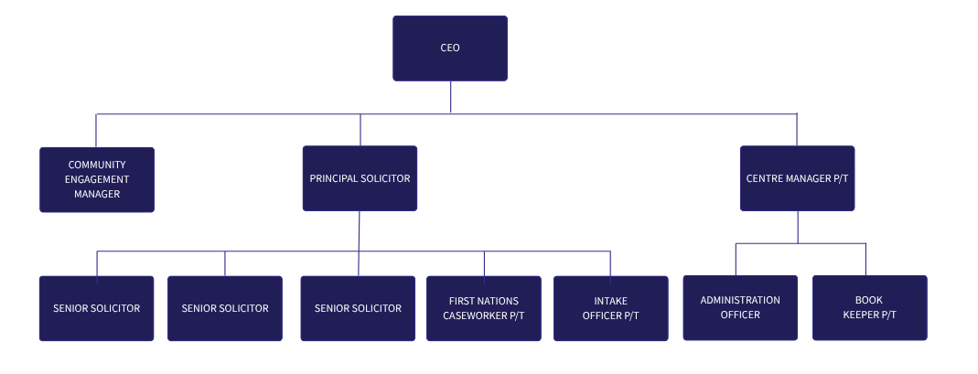
NEXT STEPS
How to apply

Applications should include:  - A current CV.  - A concise cover letter (maximum 2 pages) explaining your interest and how your experience aligns to the four priorities for the role.  - Optional: a short example of a funding, revenue or organisational change outcome you personally led.  The recruitment process is expected to include interviews with Board members and may include a practical discussion or presentation on WRC’s strategic and financial sustainability priorities. | TO CONFIRM BEFORE PUBLICATION  Closing date  13 September 2026  Enquiries recruitment@welfareright.org.au  Apply via  recruitment@welfareright.org.au or Ethical Jobs  Welfare Rights Centre welcomes applications from people with diverse backgrounds and lived experiences. We are committed to an accessible and inclusive recruitment process.
More information: welfarerightscentre.org.au

