The work and clients of CLSP CLCs in numbers
2013/14 financial year

NACLC Background Paper
for Community Legal Centres

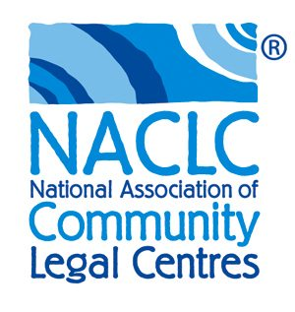

First published in September 2014 and
updated in November 2014 by:

National Association of Community Legal Centres Inc.

ABN: 67 757 001 303
ABRN: 163 101 737
(Incorporated in the ACT with limited liability of its members)

Tel: 02 9264 9595
Fax: 02 9264 9594

Mail: PO Box A2245 Sydney South NSW 1235 Australia

Email: naclc@clc.net.au

Web: www.naclc.org.au
Twitter: @NACLCComms

© 2014 National Association of Community Legal Centres Inc.

Publication is copyright. Apart from fair dealing for the purpose of private study, research, criticism or review, as permitted under the Copyright Act 1968 (Cth), no part may be reproduced by any process without written permission. Please attribute to the National Association of Community Legal Centres Inc.

Enquiries should be addressed to: naclc@clc.net.au phone 02 9264 9595.

Table of Contents

1. Background Information 4
1.1. What’s included and what is not 4
1.2. CLSIS – a live database 4
1.3. The definition of “client” 4
2. Data 5
2.1. Clients assisted 5
2.2. Legal and non-legal advices and casework files 5
2.3. Legal information provided and referrals 5
2.4. Community legal education and law reform and legal policy 6
2.5. Client demographics 7
2.6. Notes about client demographics 8
2.6.1. People with disability clients 8
2.6.2. Aboriginal and/or Torres Strait Islander clients 9

Background Information

The data in this paper comes from the Community Legal Service Information System (‘CLSIS’) database, with some data cleansing and further data analysis undertaken by NACLC’s data consultant, Finrea.

Note: All percentages have been rounded to the nearest decimal point.

What’s included and what is not
Only CLCs that receive funding under the Community Legal Services Program (‘CLSP’) are required to collect data using CLSIS. In the 2013/14 financial year, around 150 CLCs received CLSP Commonwealth and/or State CLSP funding. A few of these CLCs are not members of a CLC state/territory association. The data for these CLCs is nonetheless recorded in CLSIS and included here, as we cannot separate out their data.

Conversely, some member CLCs are not funded under CLSP and their services and client figures will not be represented here. Many CLCs that are funded through CLSP also receive funding from other funding programs or sources. That work does not have to be recorded in CLSIS - although it commonly is – and some of it is not. Regardless, the figures for these services from member CLCs are greater than those from the non-member CLCs.

Hence, overall, these figures are an underrepresentation of the total number of activities performed and the total number of clients assisted, by all member CLCs.

CLSIS – a live database
The figures provided in this background paper are accurate reports from the CLSIS database as extracted on 6 August 2014. On 4 November 2014, a minor amendment was made to the number of instances of information provided. It is important to note that as CLSIS is a live database, these figures may vary as CLCs update or amend their data records, or data ‘cleansing’ is done to correct identified anomalies.

The definition of “client”
When “client” is used in this background paper, the term refers to any person who has received either an advice or a casework service in the 2013/14 financial year.

It is important to note that if a person visits the same CLC for multiple matters (e.g, for tenancy, consumer law and child support), the CLC will record that person as one client, even though the person may have received several services, possibly across several different areas of law. Accordingly, the figure for the total number of clients assisted is lower than the total number of services provided.

Sometimes a CLC client may also attend and receive a service at more than one centre in a year. For example, family law advice at a Women’s Legal Service and social security advice from a Welfare Rights Centre. In these cases, which are less common, there will be some duplication in a count of total CLCs’ clients in CLSIS, as the one person will have been recorded as a client at both CLCs.

Data

Clients assisted
During the 2013/14 financial year, CLCs funded through the CLSP provided legal and non-legal advice and casework assistance to more than 208,756 clients.

The number of clients assisted in 2013/14 has increased by 2.3% (or 4,748 additional clients) since the last financial year.

Legal and non-legal advices and casework files
CLCs funded through CLSP provided their clients with a total of 262,633 advices for legal and non-legal matters in 2013/14.

Advices for legal and non-legal matters combined increased by 3.7% (or 9,403 additional advices) since the 2012/13 financial year.

In total, 76,389 casework files were active for legal and non-legal matters in 2013/14.

This 76,389 figure includes new cases opened in 2013/14, as well as cases that were opened in previous years and were still running in this financial year. Overall, this represented a 1.1% decrease (or 849 less active casework files) than in 2012/13.

New cases opened in 2013/14 totalled 51,239, combining legal and non-legal matters – a decrease of 3.0% (or 1,574 less new cases opened) since the last financial year. NACLC and Finrea are investigating these decreases.

Legal information provided and referrals
In 2013/14, CLCs funded through CLSP provided 175,914 individual instances of information – up by 1.9% (or 3,342 instances) from the 2012/13 financial year.

CLCs made 128,560 information referrals in 2013/14 – a 7.9% increase (or 10,156 additional referrals) over the last financial year.

Note: CLCs record instances of information and referral services that are provided as the sole service at that time to the person seeking assistance. The figures above do not include the many examples of information and referral services provided to clients by CLC workers in the course of their providing legal advice and casework services to clients. The figure representing these referrals is provided below.

For referrals provided to clients during the course of advice and casework services, CLCs made 102,412 advice and casework referrals in 2013/14.

In total, 230,972 referrals were made in the 2013/14 financial year by CLCs – this incorporates information referrals, and advice and casework referrals.

Figure 1: Profile of legal services delivered by CLCs in the 2013/14 financial year

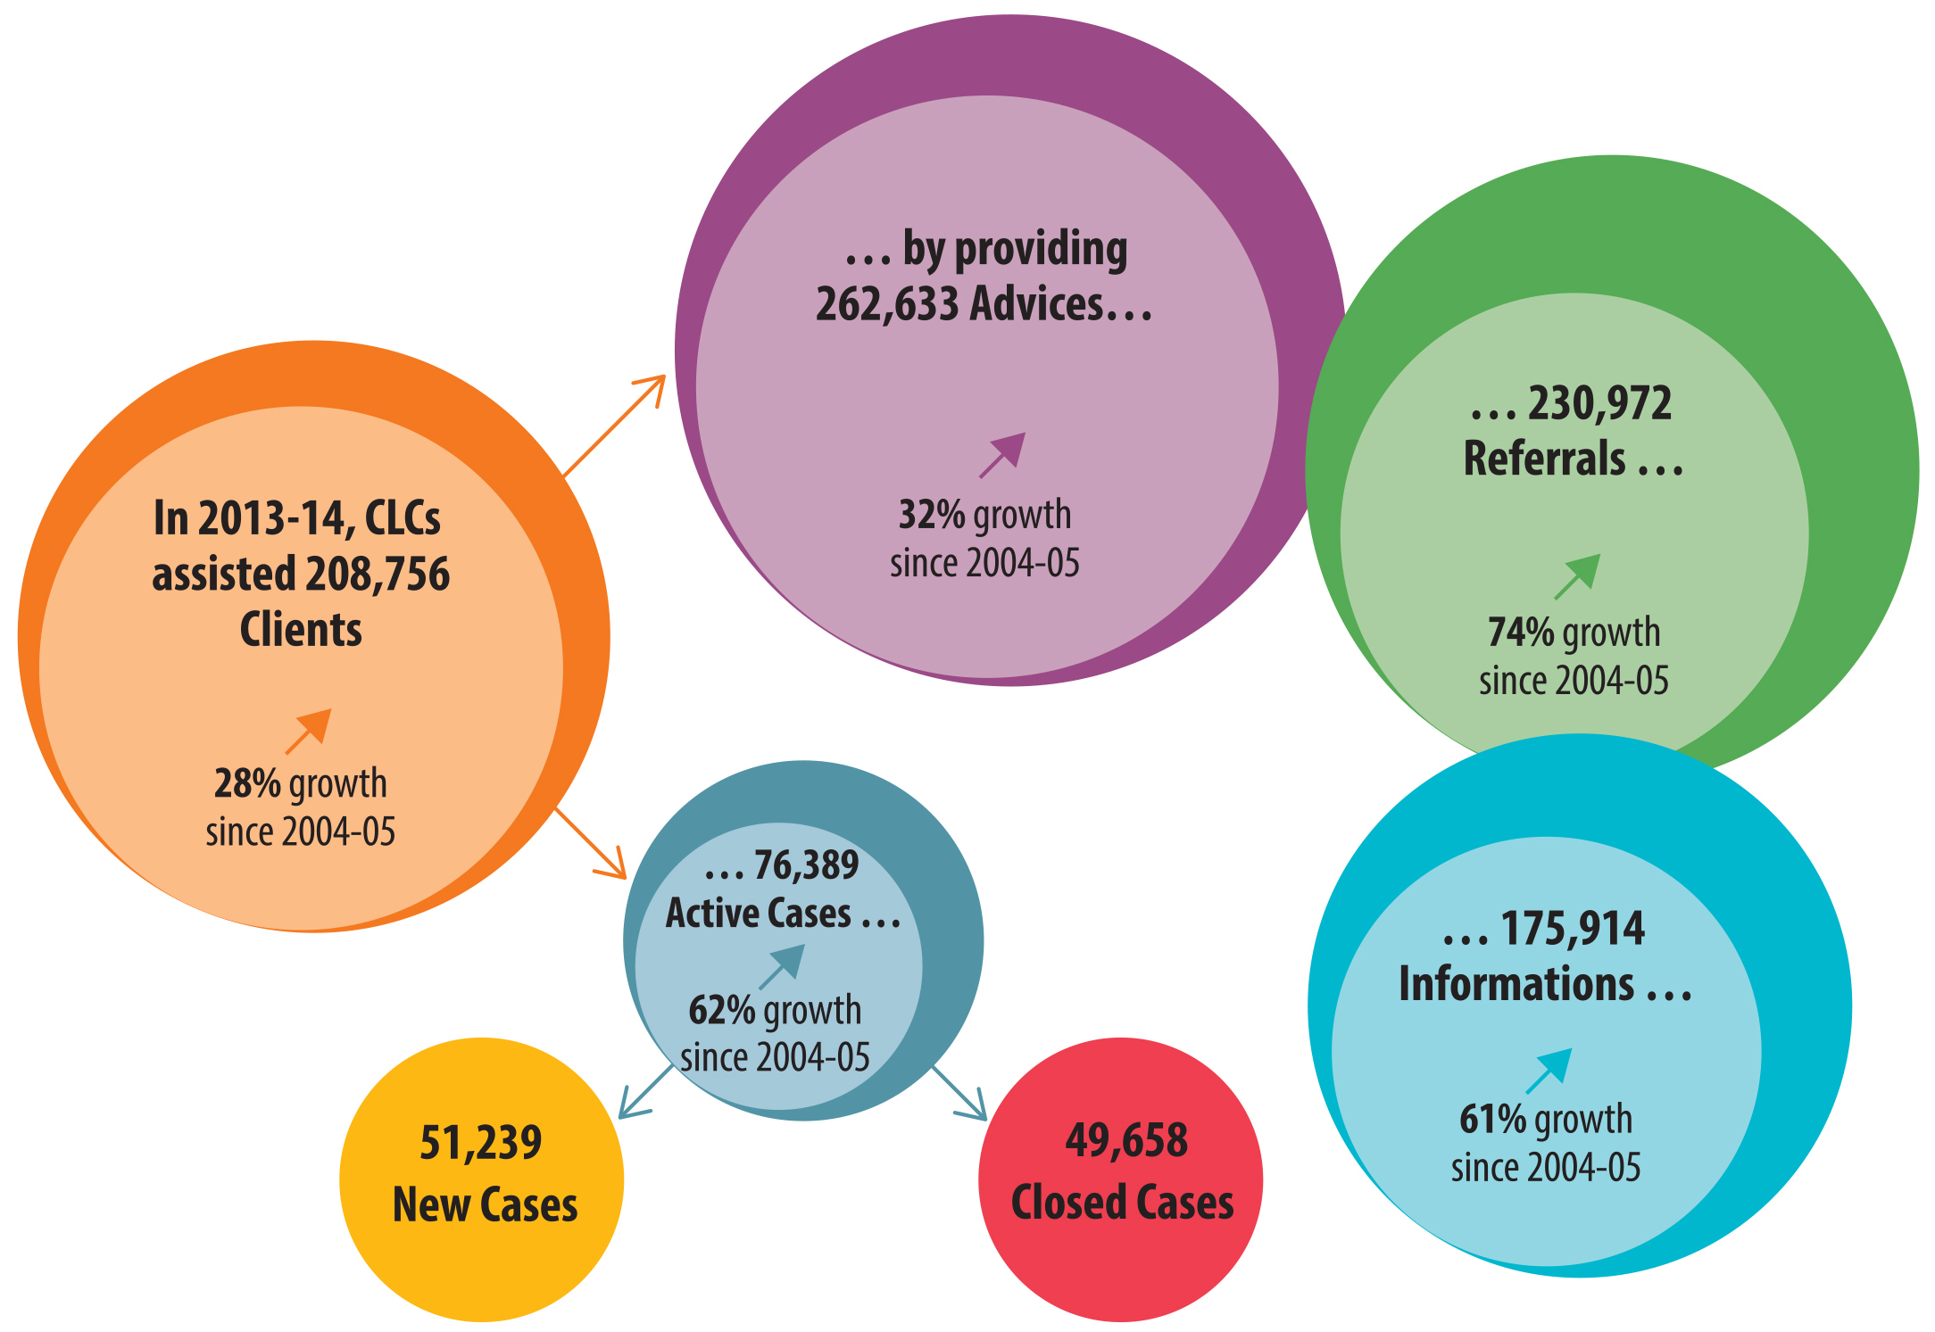

Community legal education and law reform and legal policy
During 2013/14, CLCs also completed 4,266 community legal education (CLE) projects – an increase of 7.9% (or 311 projects) from the 2012/13 financial year.

Note: CLSIS only records CLE projects when they are completed and closed – as some may continue for some time, this figure may well be an underrepresentation of the total number of CLE projects worked on in that year.

Note: CLSIS counts a CLE project as one, even when, for example, it comprises a series of legal education sessions delivered over several weeks or months if they are part of one program.

878 law reform and legal policy projects were completed in the 2013/14 financial year – a decrease of 8.4% (or 80 less projects) from the last financial year.

Note: CLSIS counts law reform and legal policy projects only when the project file is completed and closed. Many law reform and legal policy projects go over a lengthy period, so these figures are very likely to be only a proportion of the total of these types of activities that would have been worked on in this year.

The three areas of law that CLE and law reform and legal policy projects most commonly focused on in 2013/14 were: family or domestic violence, family law and problem types categorised as other civil law.

Client demographics
The data reveals the following information about the CLC clients assisted by CLCs for both legal and non-legal matters from CLSP funding in 2013/14:

- 17.2% (35,833) were living in a sole parent family with dependent children

- 18.7% (38,948) were not living in a family, but were living as a boarder; living alone; or living in a shared house, hostel or boarding house

- 6.3% (13,130) identified as Aboriginal and/or Torres Strait Islander

- 16.4% (34,297) reported having a disability

- 58.0% (121,144) were female

- 62.6% (130,651) reported having either a low or no income

- 43.7% (91,224) reported receiving a government pension, benefit or allowance (e.g, family payment, rent assistance, age pension)

- While the majority of these clients mainly spoke English at home
(85.9% / 179,366), the other three main languages were: Arabic (1.2% / 2,539), Mandarin (0.9% / 1,821) and Vietnamese (0.7% / 1,500)

Of the 208,756 clients who were provided with advice or casework, 2.0% (or 4,245 clients) had recently arrived in Australia. This represents a 9.0% increase (or 382 additional clients) from the 2012/13 financial year.

Figure 2: Profile of clients assisted by CLCs in the 2013/14 financial year

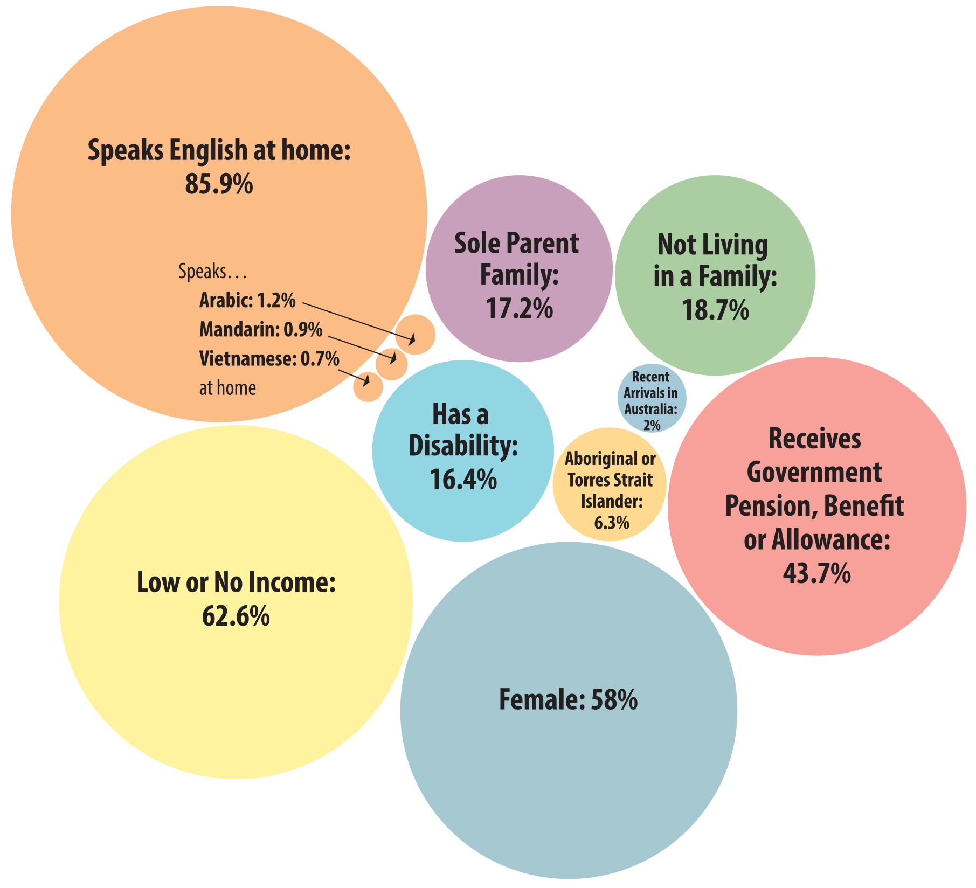

Notes about client demographics
The majority of client demographic data is collected by a CLC at the first intake, and many CLCs do not update this data once entered. Finrea is measuring changes in data entry behaviour using the new client analysis, as this gives a stronger indication of changes over time. Two areas that Finrea is particularly looking at for NACLC are the disability indicator and the Aboriginal and/or Torres Strait Islander identification indicator in CLSIS.

People with disability clients
Historically, disability collection rates for the disability indicator in CLSIS have been very poor, but have shown some improvement over the last 5 years. In the 2013/14 financial year, CLCs collected this data for 66.5% of new clients - up from 53.0% in 2009/10.

It appears that there is a strong to very strong correlation between data collection rates and disability rates. This suggests that the proportion of clients with disability is considerably underrepresented in the data. Unfortunately, there are a number of CLCs that hardly collect this data at all.

Aboriginal and/or Torres Strait Islander clients
Data collection rates for Aboriginal and/or Torres Strait Islander in CLSIS have also improved over the last 5 years. In the 2013/14 financial year, CLCs collected this data for 88.0% of new clients, up from 76.0% in 2009/10.

Unlike the data collection rates for people with disability, it seems that there is only a mild positive correlation between data collection rates and proportion of clients recorded as Aboriginal and/or Torres Strait Islander.

Analysis suggests that some CLCs have selected the ‘Neither Aboriginal nor Torres Strait Islander origin’ as the default indicator in CLSIS, so their records are showing higher numbers of non-Aboriginal and Torres Strait Islander peoples than is almost certainly the case. If this is, as we believe, correct, it is highly likely that the proportion of Aboriginal and/or Torres Strait Islander clients is under reported overall, due largely to this practice.

Notes

NACLC acknowledges the traditional owners of the lands across Australia and particularly acknowledges the Gadigal people of the Eora Nation, traditional owners of the land on which the NACLC office is situated. We pay deep respect to Elders past and present.

Figure 1 also shows the increase for some key statistics since the 2004/05 financial year.
The CLSIS Data Dictionary advises that a client should be recorded as having a low income if their weekly income is under $500 per week or $26,000 per year.
“Recently Arrived” means born overseas and arriving in Australia in the year prior to the reporting period or the current reporting year. For the 2013/14 financial year, this will include all clients who arrived from 1 January 2012 or later, and have an advice or casework in the 2013/14 financial year. Note: The rate of data collection for ‘Country of Birth’ and ‘Year of Arrival’ is very poor. This means that these figures are significant undercounts.
In CLSIS, three positive indicators are: ‘Aboriginal but not Torres Strait Islander origin’, ‘Torres Strait Islander but not Aboriginal origin’ and ‘Both Aboriginal and Torres Strait Islander origin’.

